Steven Houser
Slide and Catch Game - Part I
Game Design Document
10/31/25
Goal: Create a basic "slide and catch" game where a cauldron at the bottom of the screen catches falling candy. The player controls the cauldron's horizontal movement using arrow keys. There are two types of candy: regular candy (1 point) and bonus candy (2 points). When candy is caught, a message prints to the console showing points earned. The game runs continuously until the player closes the window.
Game Design Diagram - Game Screen:
The Game class will have several visual attributes:
• cauldron - an instance of the Cauldron class
• candies - a list containing 15 total falling objects: 10 Candy instances (1 point each) and 5 Candy2 instances (2 points each)
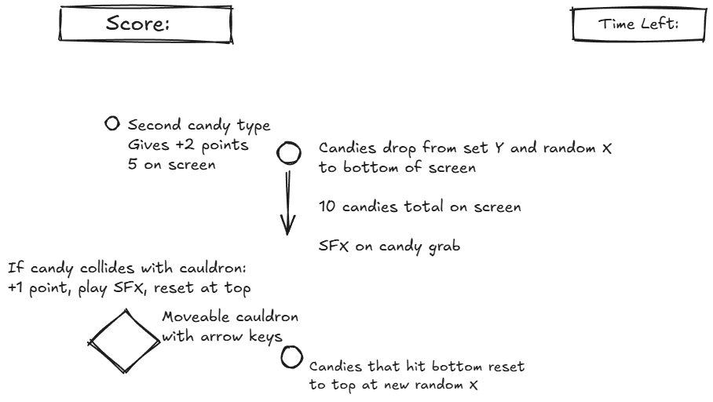
(Note: The diagram above shows the complete Week 2 version with additional features including timer, and score display labels. Part I implements the core game mechanics: cauldron, candies, and sound effects.)
Scene and Class Descriptions
Game Scene (Game class):
Variables needed:
• sndCatch (Sound effect object for candy catch sound)
• cauldron (Cauldron sprite object)
• numCandies (integer constant for number of regular candies, set to 10)
• numCandies2 (integer constant for number of bonus candies, set to 5)
• candies (list of Candy and Candy2 sprite objects - 15 total)
• sprites (list of all sprites)
init():
1. Initialize the scene
2. Set background image with try/except error handling
- If error occurs, print error message and use fallback color
3. Create sound effect object with try/except error handling
- If error occurs, print warning message and set to None
4. Create cauldron sprite
5. Set number of regular candies = 10
6. Create empty candies list
7. Use for loop to create 10 Candy sprites and add to candies list
8. Set number of bonus candies = 5
9. Use for loop to create 5 Candy2 sprites and add to candies list
10. Create sprites list with cauldron and candies
process():
1. Loop through each candy in candies list:
- Check if cauldron collides with candy
- If True:
- Play sound effect
- Print message to console showing points earned
- Reset candy position
Cauldron Sprite (Cauldron class):
Variables needed:
• moveSpeed (integer for pixels to move per frame, set to 5)
• x, y (position coordinates on screen)
• position (starting position tuple - 320, 400)
• image (sprite image)
• rect (collision rectangle)
init(scene):
1. Initialize the sprite
2. Load cauldron image with try/except error handling
- If error occurs, print error message and use placeholder
3. Set sprite size to 50x50 pixels
4. Set starting position to (320, 400)
5. Set moveSpeed = 5
process():
1. Check if LEFT arrow key is pressed
- If True: Move cauldron left by moveSpeed pixels
2. Check if RIGHT arrow key is pressed
- If True: Move cauldron right by moveSpeed pixels
Candy Sprite (Candy class):
Variables needed:
• x, y (position coordinates)
• dx, dy (movement speed components)
• points (integer value - set to 1)
• image (sprite image)
• rect (collision rectangle)
• screenWidth, screenHeight (screen dimensions)
init(scene):
1. Initialize the sprite
2. Load candy image with try/except error handling
- If error occurs, print error message and use placeholder
3. Set sprite size to 25x30 pixels
4. Set points value to 1
5. Call reset() to set starting position and speed
reset():
1. Set starting y position to top of screen (y = 10)
2. Set random x position across screen width
3. Set random downward speed (between 3 and 8 pixels per frame)
4. Set horizontal speed to 0 (moves straight down)
checkBounds():
1. Check if candy has fallen off bottom of screen
- If True: Call reset() to move candy back to top with new random position and speed
Candy2 Sprite (Candy2 class):
Variables needed:
• x, y (position coordinates)
• dx, dy (movement speed components)
• points (integer value - set to 2)
• image (sprite image)
• rect (collision rectangle)
• screenWidth, screenHeight (screen dimensions)
init(scene):
1. Initialize the sprite
2. Load candy2 image with try/except error handling
- If error occurs, print error message and use placeholder (orange color)
3. Set sprite size to 25x30 pixels
4. Set points value to 2
5. Call reset() to set starting position and speed
reset():
1. Set starting y position to top of screen (y = 10)
2. Set random x position across screen width
3. Set random downward speed (between 3 and 8 pixels per frame)
4. Set horizontal speed to 0 (moves straight down)
checkBounds():
1. Check if candy has fallen off bottom of screen
- If True: Call reset() to move candy back to top with new random position and speed
Main Function:
Variables needed:
• game (Game scene object)
main():
1. Import pygame, random, and simpleGE modules
2. Create Game scene
3. Start Game scene
4. Program ends when window is closed
Assets:
Background Image:
• File: background.png
• Used for Game scene
• Source: https://craftpix.net/freebies/free-halloween-2d-game-backgrounds/?num=1&count=10&sq=halloween&pos=4
Cauldron Sprite:
• File: cauldron.png
• Source: https://katy-elizabeth.itch.io/halloween-props-pack-2
Candy Sprite (1 point):
• File: candy1.png
• Source: https://katy-elizabeth.itch.io/halloween-props-pack-2
Candy2 Sprite (2 points):
• File: candy2.png
• Source: https://katy-elizabeth.itch.io/halloween-props-pack-2
Sound Effect:
• File: catch.wav
• Plays when candy is caught
• Source: https://freesound.org/people/Mihacappy/sounds/828150/

